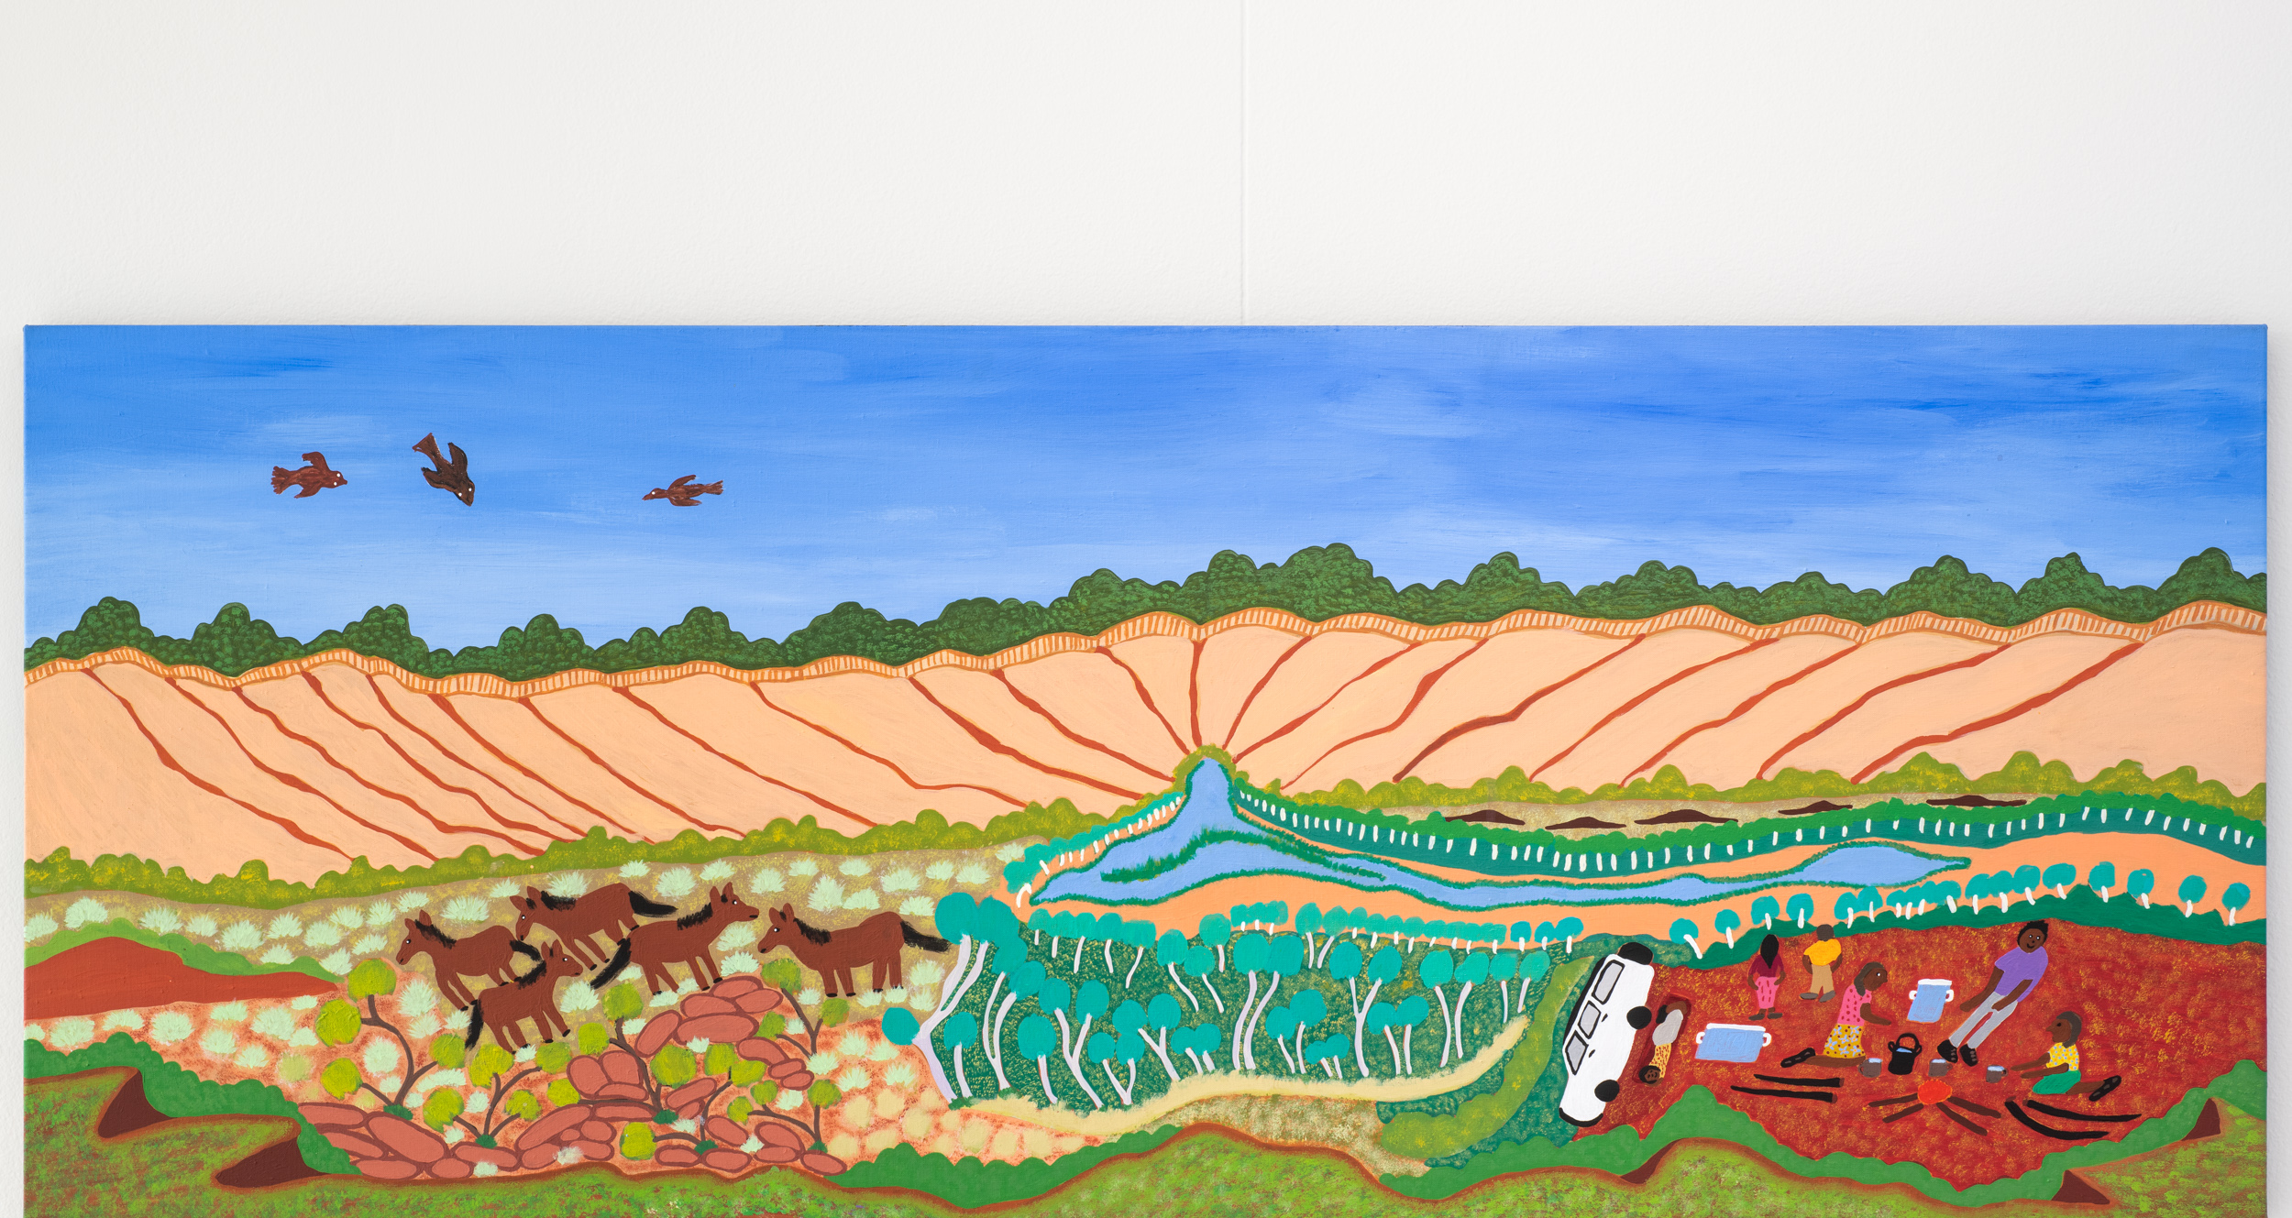
First Nations Scholarship
Slattery Australia

First Nations Scholarship

Quantity Surveyor Cadetship
Application Form
Quantity Surveyor Cadetship Application
Slattery is excited to announce the launch of our inaugural First Nations Scholarship Program.
This opportunity extends to four Aboriginal or Torres Strait Islander students, 2 in Melbourne (Naarm) and 2 in Sydney (Cadi), who obtain successful entry into a Construction or Engineering related tertiary degree for 2022.
Slattery is proud to have reached Innovate status for our Reconciliation Action Plan – to read more, please see our website.
The details of the scholarship are:
Duration:
Three (3) years (option to extend to 4 years)
Employment:
Two (2) days per week permanent paid employment over the course of the student’s degree, including mentoring and career development opportunities
How to Apply
To apply for the Slattery First Nations Scholarship, please send a complete application form to careers@slattery.com.au.
Applications must include the mandatory selection criteria listed below.
Applications must be submitted by 5pm, 25th February, 2022.
Application & Selection Process
Shortlisted applicants will be reviewed and assessed by a panel including Slattery staff (a mix of gender and age) and Yemurraki Egan, Yorta Yorta, Wemba Wemba & Gunditjmara man. Yemurraki is engaged by Slattery as an external First Nations Consultant and is a part of Slattery’s Reconciliation Action Plan Working Group.
In addition to the mandatory criteria, the panel will be seeking:
- Alignment with Slattery core values
- Excellent communication skills
Shortlisted candidates will be contacted and invited to interview with members of the selection panel. Successful applicants will be notified of the scholarship offer by 15th March 2022.
Applicants will be notified of the outcome via phone and email, so please ensure this is correct on your application form.
Mandatory Selection Criteria
- Aboriginal or Torres Strait Islander student
- Confirmation of acceptance into a Construction or Engineering related tertiary degree in 2022
- Based in Victoria or NSW and able to attend offices in Melbourne or Sydney
- Completion of Application Form, including the ‘About You’ section of the form.
A copy of the Required Attachments as listed below
Optional
- CV summarising your education and work experience

Required Attachments:
- Proof of identification (scanned photo ID)
- Evidence or formal confirmation of your acceptance into a Construction or Engineering related Tertiary degree you have been accepted into for 2022

For Further Information
If you have any questions regarding our Scholarship Program, or the application process please contact Belinda Coates, Belinda.coates@slattery.com.au or 0419 803 698

First Nations Scholarship
Quantity Surveyor Cadetship Application
Complete the following questions to the best of your ability.
Please attached all required documentation at the end of your complete application.
Once complete, email the final application and all required attachments to careers@slattery.com.au
General Details of Applicant
Full Name
Date of Birth
Home Address
Postal Address (if different)
Phone Number (Home)
Phone Number (Mobile)*
Primary Email*
Do you Identify as Aboriginal or Torres Strait Islander or both?
Which Traditional Owner language group do you identify with?
(If you do not know please put N/A)
Name of University you are enrolled in for 2022
Name of Construction or Engineering related Tertiary degree you have been accepted into for 2022

About you
Briefly outline why you are interested in this scholarship with Slattery, and why you think you would be a suitable/the best candidate.
400 words max
Briefly describe your career aspirations and why you have decided to pursue a degree in a construction related industry?
400 words max
Briefly describe one of your proudest personal achievements or accomplishments, and why you’re proud of it.
400 words max
Other
How did you find out about the Slattery First Nations Scholarship Program?

